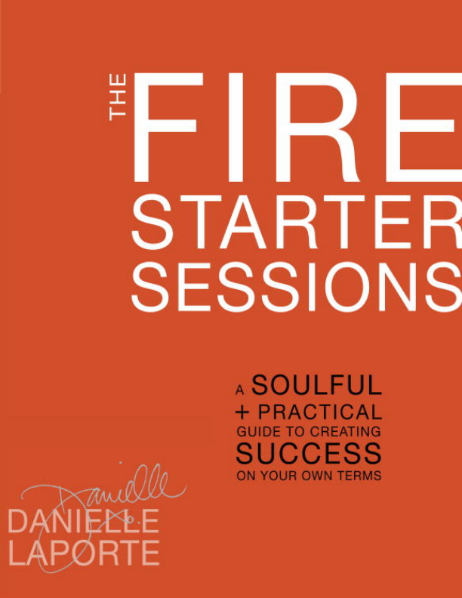
“Wise, engaging, and, above all, different.”
—Michael Bungay Stanier,
Do More Great Work
“She tells the truth, straight up. Money, failure, power, appreciation— The Fire Starter Sessions doesn’t leave anything out of the mix, and Danielle pours it on with a heaping dose of encouragement and possibility-thinking.”
—Barbara Stanny, Overcoming Underearning
“Danielle’s work is jam-packed with keen insights and a force of energy that pushes you in invaluable ways. The content is practical and ignites the mind in ways that could change your career and life.” —Scott Belsky, Making Ideas Happen
“Danielle LaPorte is scary smart, yet so kind and practical that she kindles the fire in you without causing you to feel consumed by the flames. She has the knowledge you need to succeed. Lean in and listen close. What she has to say is what our spirits need to hear.”
—Martha Beck, Steering by Starlight
“Danielle is one serious Fire Starter, and you’ll be one, too, after reading this masterpiece. For best results, read in your igloo and emerge with a suntan.”
—Chris Guillebeau, The Art of Non-Conformity
“Danielle’s passion leaps off the page, and reading a few chapters of this book will ignite you into action.”
—Gretchen Rubin, The Happiness Project
“The revolution you’ve been waiting for, it will shake up and wake up every aspect of your life. Danielle LaPorte offers soulful wisdom to create a blueprint for moguls, spiritual rock stars, and lovers of life. Skinny-dip head first into this hot and fabulous book. I dare you.”
—Kris Carr, Crazy Sexy Diet
“A modern masterpiece that will impact millions of lives, for generations to come. It’s outrageously inspiring, wise, and actionable. I simply cannot recommend it enough. Prepare for a religious experience. You’re going to fall in love with this book.”
—Marie Forleo, www.MarieForleo.com
“The new, badass Artist’s Way.”
—Linda Sivertsen, Generation Green
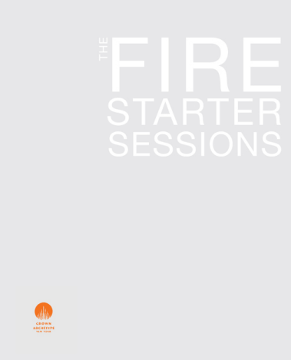
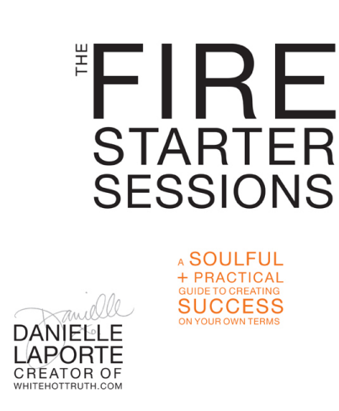
Copyright © 2012 by Danielle LaPorte, Inc.
All rights reserved.
Published in the United States by Crown Archetype, an imprint of the Crown Publishing Group, a division of Random House, Inc., New York.
www.crownpublishing.com
Crown Archetype with colophon is a trademark of Random House, Inc. Library of Congress Cataloging-in-Publication Data
LaPorte, Danielle,
The fire starter sessions / Danielle LaPorte. — 1st ed.
p. cm.
1. Self-actualization (Psychology) 2. Self-realization. 3. Quality of work life. 4. Social entrepreneurship. I. Title.
BF637.S4L358 2012
158.1—dc23
eISBN: 978-0-307-95212-7
Cover design by Maria Elias
v3.1_r1
It is not revolutions and upheavals that clear the road to…better days, but revelations, and lavishness…of someone’s soul, inspired and ablaze.
—Boris Pasternak, poet
CONNECTING
Everything about the book and extra-hot stuff:
TheFireStarterSessions.com
Connect to my universe here: DanielleLaPorte.com
Find me on + Fire Starter reports on Facebook:
www.daniellelaporte.com/facebook
I love Twitter, a lot: @daniellelaporte
Twitter hashtag for The Fire Starter Sessions: #FireSS
Get multidimensional with me—
this is more than a book.
TheFireStarterSessions.com is an extended experience where you can access:
• The Workbook o’ Fire, a free downloadable booklet of the worksheet questions from the book.
• The Camp Fire Guide, a free guide for creating a book club or group experience.
• A companion video program, an online community, resource lists… and plenty of other treats and truly useful tools.
CONTENTS
Disclaimers + Admissions
Come, Sit by the Fire…
PART 1
MOJO
Define Yourself on Your Own Terms
SESSION 1
Declare Your Superpowers
WORKSHEET: PASSION PLAY
SESSION 2
The Metrics of Ease
WORKSHEET: EASY PRIORITIES
SESSION 3
The Strategy of Desire
WORKSHEET: CORE DESIRED FEELINGS
PART 2
MOXIE
SESSION 4
The Burning Questions
WORKSHEET: THE BURNING QUESTIONS
SESSION 5
Facing Forward
WORKSHEET: PURGE THE PAST URGE
WORKSHEET: GLORY BOARDING
SESSION 6
Visioneering
WORKSHEET: VISION PROMPTING
WORKSHEET: DREAM ANALYSIS
SESSION 7
Fear + Other Tough Stuff
WORKSHEET: DECONSTRUCTING FEAR
SESSION 8
Comforting Failure
WORKSHEET: COMFORT ZONING
SESSION 9
No, Thank You. Yes, Please.
WORKSHEET: THE STOP-DOING LIST
PART 3
RESULTS
SESSION 10
Make Stuff That Feels Good to Make WORKSHEET: WHAT BUSINESS ARE YOU REALLY IN?
SESSION 11
How You Show Up in the World WORKSHEET: THE ALL-ABOUT-YOU INTERVIEW
WORKSHEET: THE ASK-A-FRIEND SURVEY
SESSION 12
Calling All Sovereigns of Time!
WORKSHEET: A PERFECT TWELVE
SESSION 13
Money: More Is More. Enough Is Plenty. WORKSHEET: FREELY ASSOCIATING WITH MONEY
SESSION 14
Supporting Characters
WORKSHEET: SIZING UP SIMPATICO
WORKSHEET: SUPPORT TEAM INVENTORY
SESSION 15
Be the Giver
SESSION 16
Just Start. Now.
WORKSHEET: FUTURE GRATITUDE
Great, Full
The Sonic Fire Playlist
Spread the Fire
DISCLAIMERS +
ADMISSIONS
1. There is nothing I can give you that you don’t already have. Some of you will find this notion wildly arousing and affirming. Yeah! Others may experience instant despair. What? Isn’t this a self-HELP book? Fret not. We’re going to shine a light on the deeply inherent good stuff you have to give—and there’s plenty of it.
2. It all comes down to this: You become a trailblazer by virtue of being your genuine self. It is that simple—and that profound.
3. I admit it: I want to be your favorite pyromaniac of clarity, love fueled ambition, and results.
4. I may not know you, but I love you already. There, I said it. LoveLove,
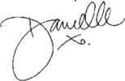
COME,
SIT BY THE FIRE…
When being real is your priority, the various parts of your life start to groove. Your career will begin to reflect your true passion; your living room will match your values; your friends will fit your soul; and your wealth—of which there are many definitions—will start to measure up with your notion of freedom. Sometimes the courage to be true to yourself comes in the form of an out-loud declaration, a rebellion, or a love-drenched vow. Other times it’s a quiet conviction that we can read in your eyes. Mighty or discreet, authenticity is the muscle that helps you shake up beliefs, policies, and restraints, and gives you the strength to do the things some say can’t be done. Being genuine is the foundation of integrity—often inconvenient and not always painless— but the only way to go if you’re here to really, truly, fully live.
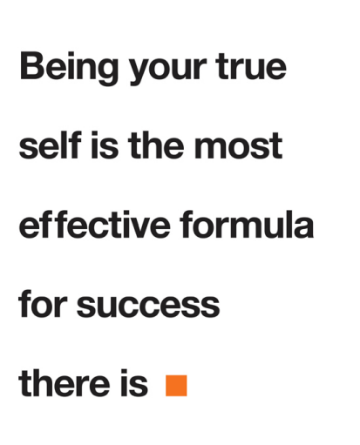
They don’t tell us that in most schools or time management seminars. And not many employee manuals instruct you to:
Be strategic with your desires.
Leverage your contradictions.
Say no to resentment and yes to inspiration.
Make ease a metric of success.
These precepts are kindling for your soul fire, they are the pathways to what you truly want, and they are the reason this book exists.
SOUL FIRE
Our soul fire is ancient and integral to each of us—inextinguishable, but susceptible to being dimmed to faintness. It can get cloaked in layers of self-doubt. We doubt the practicality of enthusiasm and the legitimacy of our impulses. We doubt that breaking the rules will earn us a raise or that speaking in the first person will attract the right clients. We worry that our shine will be construed as showing off and we’ll get shot down; or that if we really let our opinions flare, we’ll burn bridges that we may need to cross again someday.
Self-doubt is so insidious that it not only renders us stuck in our lives, but it also actually weakens our ability to dream about what living unleashed would look like. And here’s the thing: The mere act of dreaming is a vitalizing, life-affirming endeavor. As it turns out, using your imagination is very, very good for your well-being. Einstein believed that imagination was even more important than knowledge itself.
Imagine your ideal life as a mountain of treasures piled high in front of you. It’s in the near distance, close enough to walk to on your lunch break. Pile up that mountain o’ delight with whatever you want: gold bullion, flat abs, laughing friends, really good times with your family, a
career that is bursting with gratification and intrigue, the love of your life, applause and respect, cheers when you cross the finish line, eco friendly everything, humanitarian relief efforts, the wealth of health, a five-speed coupe with a sunroof, a first-class trip to Monaco, light rays of illumination and peace emanating from you so as to attract devotees or babes (or both). Throw in some multiple orgasms and a fat year-end bonus if that feels good. (That does feel good, right?)
You’re standing at a fork in the road. Presumably, both roads will lead to your ideal life. There are two signs pointing to your destination.
One says YOUR WAY.
The other says THEIR WAY.
Which path do you think will be more fun? Never mind about enlightenment or building your credibility. Which path will have more free falls and heart rushes, more laughs, more daring?
If you’re thinking that THEIR WAY has some inviting merits, you’re right; it does. And I’m not being cynical. THEIR WAY is proven. And “proven” can save you a lot of time and heartache. My role models’ victories and bankruptcies, both spiritual and financial, have saved me from expensive mistakes and leveled out my learning curve. The way my soul sisters live their lives deeply influences the choices that I make in my own life. Have you ever said to a friend, in so many words, “Geez, sorry you had to go through that, but now I don’t have to. Thanks, man.” Among true friends it’s obvious that we’re learning lessons for one another, sparing each other some pain, eating some karma for team.
You can steer your destiny. You can create the life you want in great detail, but you can’t do it alone. THEIR WAY can be very instructive and comforting. And comfort is a beautiful thing when you’re risking it all.
But THEIR WAY is an old story. Albeit potentially useful, it’s history. It’s a myth of experience that we can choose to buy in to or not. Be clear about that. Take what you want from the tried ’n’ true archives, and leave the rest. Ultimately, it’s all your call. Even when stuff seems out
of your control, you get to choose how you respond—or react—to everything.
YOUR WAY. Slightly reckless, downright defiant, uncharted, seat-of-the pants, make it up as you go, not a leg to stand on, what will your mother say? You could bomb. You could become so successful that your friends won’t recognize you. (Your real friends always knew you
had it in you.) You could break through.
YOUR WAY
The soul fire way.
Ablaze with passion.
Passion that can’t be faked.
Passion that the world cannot deny.
DESIRE MORE
This experience—this book and all of the materials on the website—is intended to help you “up” your dreams, to revive or refine them. I want you to make dream refinement a regular practice. Floss, stretch, eat your greens, dream. And repeat.
Your desires reflect what’s truest about you. If your current reality is nowhere close to the life you want, dreams are the fuel that will move you forward. If you want to access your full range of power, then commit to dreaming about your ideal life. Your subconscious and articulated desires are veins of gold that lead to whatever you want to call prosperity.
No matter where you are in your life, whether you’re a soaring entrepreneur or an executive in a rut, a student revving up to save the planet or a stay-at-home mom with an identity crisis, an urban shaman wandering or well established, you need to consciously cultivate your dreams. We need to tend to our desires with the same
vigilance that we would give to the fire that cooks our food, warms our bones in the night, and keeps the wolves away. Of course, tending to your deep wishes is not a matter of bodily life or death. Without passion, you can still make the rent, be a good guy, and limp along for lifetimes—as many of us do. You’ll survive. But we’re not here to talk about surviving or justifying just getting by. This book is an inquiry into what makes you thrive.
IDEALISTS UNITE!
There is nothing more turned on than a person with a dream and the guts to pick up the phone. Dreaming is essential, but it’s only part of the equation. You’ve got to put a strategy into play. (All the overachievers out there are like, Duh! Milestones, people, milestones!) Passion is the wind in your sails, and practicality is the rudder. You need both to get where you’re going.
As the saying goes, “The truth is that which works.” You can manage your time like a ninja, make vision boards, and set quarterly goals till the future’s so bright you gotta wear shades, but if all those systems don’t work, then something’s…not working. You can meditate till your sit bones are blue, pray, process, train, affirm, think positive, therapize, and if you’re still not a calmer, more generous person who speaks kindly to the waiter and takes traffic jams in stride, then maybe how you measure the results of your questing needs to be recalibrated.
If your soul fire still looks like it’s just flickering in the distance, a mile outside of you, then it’s time to consider what gets you hot in the here and now. This may be a radical consideration.
The CEO of a billion-dollar entertainment company once said to me, “There’s evolutionary and there’s revolutionary. Evolutionary is a degree of change, but revolutionary changes everything.” He continued, “Take Starbucks, for example. They revolutionized the coffee business. Anyone who follows will be merely evolutionary. And evolutionary is good—it’s solid; it can be quite fulfilling. But
revolutions! Ah…that’s the really exciting stuff. Who doesn’t want to be revolutionary?! Which would you rather be?”
I’m going for revolutionary, thank you. Not warm—hot. Not bright— blazing.
The hallmark of revolutionary change is that it beams out to the point of irrepressible, and it affects change in those who witness or experience it. Inward and outward revolutions happen every day. You don’t necessarily have to lead a nation to independence or take on the union reps (but by all means…if the spirit moves you)…A revolution can be a whole new perspective that changes the way you work, achieve wellness, or thrive in a relationship. A revolution is a way of being that becomes a significantly better way of doing. And it shifts and lifts people up along with you and keeps the universe on the edge of itself. A Course in Miracles defines a miracle as “a shift in perception.” Revolutions can feel miraculous.
HEAVY HEART LIFTING
Starting fires and revolutions requires tenacity and faith. And those are hard to come by when you’re feeling stuck and spirit fatigued. Spirit fatigue is a malaise with many names: Listlessness. Depression. Incessant resentment. Chronic doubt. Numbness. Feeling small. A persistent fear of loss. Throw in a bad breakup, chemical imbalances, getting downsized, an accident, too much processed food, and the fear-drenched headlines otherwise known as the daily news, and we can veer toward overwhelmed.
When you’re physically injured, the rest of your body will make adjustments to compensate for the weakened part. It will carry the brunt in order to endure and carry on, so much so that you don’t even notice that the rest of you is knotted up and fatigued. Psychologically we can limp on for years with aching hearts and vexations, just mobile enough to manage day-to-day existence. If you’re spirit fatigued for long enough, you will downshift into unconscious enduring. You endure the doubt, and the gray hue, and the disconnectedness. You’ll begin to believe that if it’s this hard for so many of us, for so long, then
that must just be the way it is. And so you make adjustments to your desires. You amend your hopes. You repeatedly ignore your hunger. When we’re spirit-fatigued, we tend to make weak decisions. We compromise. And I’m not talking about the Good Samaritan compromise where you step outside of yourself and do something accommodating for other people. I’m talking about the sell-yourself short kind of compromise. You know, where you tell yourself that you don’t really deserve to want what you want. (It’s so much to ask for.) That you should be more accommodating. (It’s more spiritual to be nice.) That you really should be more reasonable. (Logical people are so much more bankable than the emotional types.) And this killer concept: This is as good as it gets.
These are the very notions that veil the light of your essential self and keep you from what you want the most.
BRAKE FOR PEACE
I have been running so sweaty my whole life
Urgent for a finish line
And I have been missing the rapture this whole time
Of being forever incomplete
—Alanis Morissette, “Incomplete”
The Path. The Way. The Formula. The Secret. The Answer. The Answer to the Secret. The All-New Way to the Path That Leads to the Secret Formula…in Ten Steps or Twenty-one Days—whichever comes first. So many of us are always driving, nonstop, in hopes of arriving at peace, or unshakable confidence, or somewhere further down the street from anxiety. It’s the irony of chasing stillness—or trying to get ahead so we can get out of the game. Or of improving ourselves so we can finally accept who we are. It’s exhausting.
Humans are gloriously determined to get what they want. We’re ridiculously insatiable. We have a propensity for craving—ceaselessly. Buddhists, who are always trying to detach from this wheel of suffering
wouldagree: Constant craving canbeabitch. But on theotherendof longing, there is some good news:
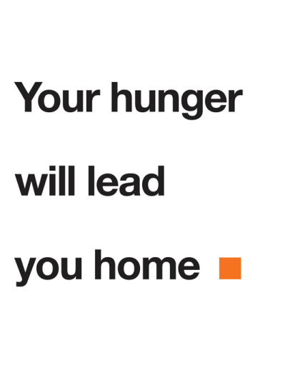
HAPPINESS IS CREATIVE TENSION
The Fire Starter Sessions is like a mixed CD of apathy-kicking sermons and love-soaked questions. We’re going to consider the contradictions that make you so gorgeously multidimensional but aren’t so easy to reconcile. Your spicy, finicky, idiosyncratic-isms. This tension is where your creativity likes to hang. Tension. Creates.
If we want to live bold, full lives, we must take our whole selves into the future. Nothing can be forsaken or hidden, because it is in integrating all of the aspects of our beings that we expand. Cosmic love and worldly ambition, consciousness and cash, high standards and compassion—this is where it all comes together. And I’ll tell you up front that this is really a covert campaign for generosity. Generous, fulfilling outpourings of whatever you’ve got to give. If you’re fully showing up for life, you won’t be able to tell the difference between selflessness and self-serving because it feels so good to give…or is it receiving?
We’re going to get gritty and gracious all in one breath. Success is messy. Career visions spill into lifestyle choices, mash into spiritual paradigms, and ride on top of relationships. It’s all interconnected and paradoxical. And promising.
Wisdom comes from embracing contrasting experiences: Lucky breaks and pounding the pavement. A winning streak and a dark night of the soul. Selling out and taking a stand. Wanting it all and walking away.
If wisdom comes from integrating the highs and lows of life, then fulfillment is the result of bringing your whole self to the game. All of you. Not just the politically correct and the well-behaved bits. Not just your master’s degree and certifications. And not only your unbounded passion—because putting your passion into form will take all of the mental muscle that you can flex.
IN·TEG·RI·TY (NOUN)
1. adherence to ethical principles; soundness of moral character; honesty
2. the state of being whole, entire, or undiminished
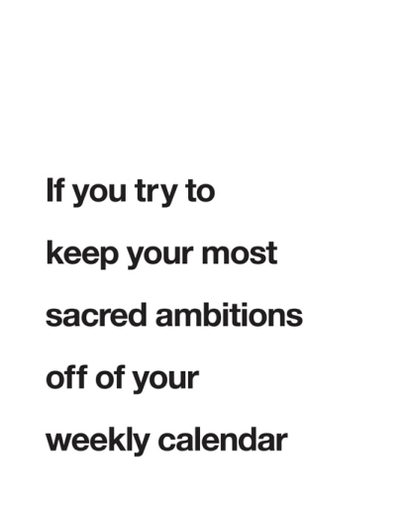
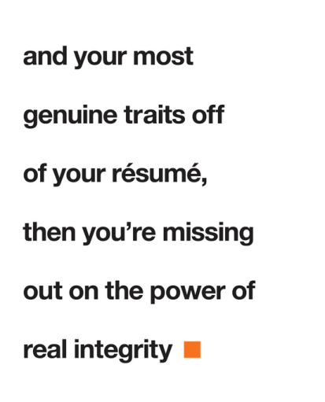
THE HEAT SOURCE
The Fire Starter Sessions uses career and creativity as levers to expanding your awareness. I don’t think you can have a conversation about consciousness without talking about how you show up every day in the world of moneymaking and service. Livelihood is a portal to our personal and collective growth: How we serve, make art, make ends meet. What we earn, how we value ourselves. Work. Labor. Love. Craft. Calling.
As a business and creative strategist, I’ve worked with hundreds and hundreds of people to help take their visions to the next level. I’ve done live Fire Starter Sessions with groups in theaters, in boardrooms, on the beach, in living rooms, even in a pole-dancing studio in Los Angeles. I’ve jammed with a best-selling author who still feels she’s living in the shadow of her best-selling father; a Buddhist minimalist who wants to crack six figures a year; a socialite stockbroker who wants to write the next great novel and come out of the closet (not necessarily in that order). I’ve worked with stay-at-home moms racked with guilt because they’re itching to get back to work, and MBAs who want to drop out of the game and make babies. I’ve worked with marine biologists who want to bring science to the people and the people to the politicians; a sax player on the finer points of commerce meeting art; a surgeon who wants to be a global virtual coach for wellness; and CEOs who want to start over.
I’ve witnessed life reinventions, joyous emancipation from cubicles, and tripled incomes. I’ve cheered decisions to walk away from long term relationships—both professional and romantic—and to tackle piles of emotional and material clutter. I’ve encouraged people to hold on just a little while longer.
I’ve watched people give in to fear and rationalize playing it safe. They circle back to the fire, eventually.
I’ve heard countless “Hell, yes! I’m worth so much more!” revelations. I cherish these epiphanies of self-worth the most, and seeing someone take intelligent steps toward joy, walking away from the obligations and illusions that cramp their heart’s desire.
This I know to be true: We are craving to play bigger, to go deeper, to shine.
anything or anyone
that does not bring you alive
is too small for you
—David Whyte, poet
So my beloved Fire Starters, my freedom seekers and fear tamers, in the name of undiminished soul fire and good times, we are gathered here to get clear on what true success truly means to you. Let’s fan those flames in your heart with colossal and microscopic questions. Let’s blaze new trails in your synapses with pondered possibilities and stories of proven courage. Let’s turn up the heat on your desires. Because when you set your own light free, you become a veritable force of nature.
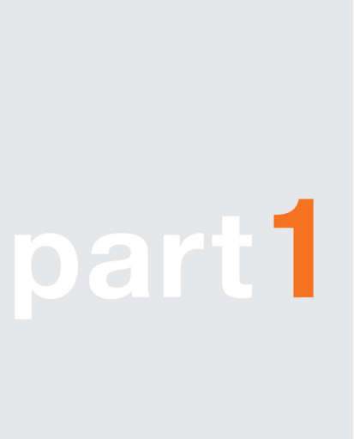
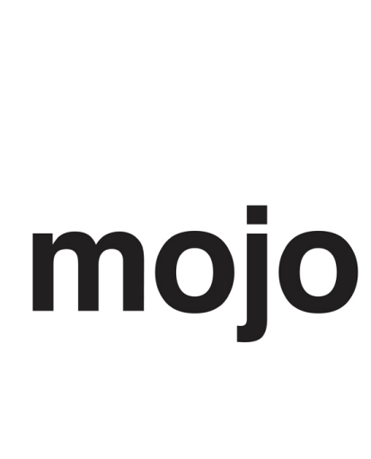
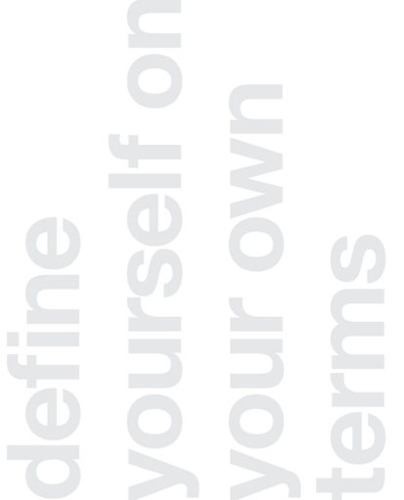
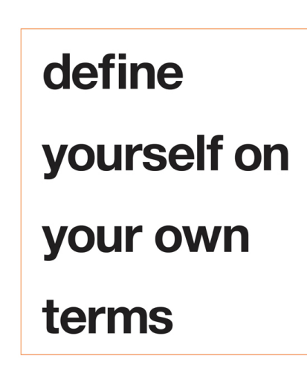
I found out that there
weren’t too many limitations,
if I did it my way.
—Johnny Cash
THE TRUTH PUNCTUATES
You shouldn’t take advice from someone you don’t really know, who hasn’t dreamed big, or suffered for a spell. Or with whom you haven’t experienced at least one major religious holiday. The Sessions that await you abound with righteous persuasions and advice. Thus, you and I should get a bit more acquainted. So before you get to the business of soul unfurling and ambition refining, and taking my word on any of it, allow me to introduce myself by way of a very defining moment in my life.
We had the corner table at JJ Bean café on Commercial Drive and Sixth in Vancouver. There were loan documents, term sheets, and talking points piled next to my peppermint tea. I was looking to Lance, my investor and mentor, to give me some straight-up sage advice. My company was being torn apart by a clash of wills and motives. It was wretched. Everything was on the line: hundreds of thousands of dollars, five years of full-tilt labor and love, long-term relationships, reputations—a very big dream. I had a lawyer (two of them). I had a business coach. I had a Buddhist shrink. What I needed was a friend with hard-core business acumen—someone who knew the ropes and who knew me.
I had that desperate “What should I do?” crease across my forehead. I was pushing hard for answers, somersaulting over Scenario A or B or… Z. Lance made it clear, with his eyes twinkling. He said:
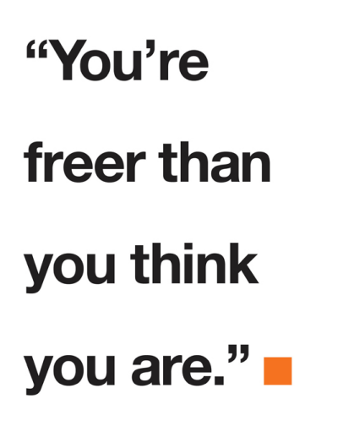
You must be kidding me. Free? I’d never felt so trapped in my life. The pressure was a whole new phenomenon in my nervous system. Bankers were calling my cell phone, investors were having clandestine meetings without me, and my once beloved business partner and I hadn’t spoken to each other in months.…
TRIAL BY FIRE: HOW I GOT HERE
I have a degree in faking it till you make it. I earned it, and then I burned it. In 2000, I was wearing a black suit and loafers, with a straight bob haircut. As executive director of a Washington, D.C.– based think tank of world-class futurists, I shopped white papers to the Pentagon and the World Bank. I wrangled an incredible team of quirky, Mensa-level thinkers to surmise and analyze potential outcomes for the AIDS epidemic in Africa, possible global water shortages, chaotic social meltdowns…and stuff like that. In terms of think tanks, it was Candy Land. Smart, fast-moving, and funded. Almost daily I was asked where I went to college (I didn’t), and to sign yet another nondisclosure agreement (which I did). From nine to five, I read about weapons of mass destruction and scenario planning; on weekends, it was Rilke’s poetry, Jiddu Krishnamurti’s theology, and the latest Rolling Stone.
James Carville said that “D.C. is Hollywood for ugly people.” Think tanks are a bit glam in the Capitol. But behind my title and White House security pass, I was managing a raging impostor complex. I craved pop culture and mysticism. My, uh, progressive attitude clashed with the policies and posturing that is the fabric of the political scene. In my first month in town, I showed up to a White House meeting with purple streaks in my hair. I may as well have flashed a KGB badge when I pulled up to the table. The meeting chair took me aside afterward. “You’re not from here, are you?” he said with a wink.
I was learning a lot, but mostly I was wilting inside. Eventually I resigned. More accurately, I fled, back to my homeland, burned out and confused. I looked at my loafers and thought, “Who the hell
bought those?” I schlepped my suits to the consignment store, dyed my hair bright red, pierced my nose, and got some new tattoos. Naturally.
Then came the inevitable identity crisis and searching. There was a sojourn to India for a private meeting with the Dalai Lama, time in ashrams and retreat centers, tea with Eckhart Tolle. In order to make the rent, I revived my old communications and publicity agency “for visionary people and projects,” and I did what I swore I’d never do again: hustled other people’s ideas to jaded television producers and radio show hosts. Meanwhile, some friends and I were plotting to raise a million bucks to open an urban spa-meets-yoga-studio-meets community-center-meets-organic-restaurant-meets-boutique (and we could franchise!). Then I woke up to the obvious fact that I didn’t want to do anything that involved having a set of master keys or giving staff performance reviews. I tried to get into art school. I still have that rejection letter.
And then a new opportunity presented itself. After months of wandering and awkward networking, I joined forces with a hardworking friend who had a good idea. She had the inspired concept, I had the brains for getting stuff out the door, and we both had a lotta style. We quickly and successfully launched what could most simply be called an image consultancy company…with soul.
This was a quantum leap toward my truer calling. I was wearing linen tunics and twisted my hair into dreadlocks. We raised hundreds of thousands of dollars in investment capital and hired a hotshot CEO to run the show. I wrote our flagship book, and my partner art directed it. The Oprah Show producers called. Magazines flew in photographers to take our picture. Major TV networks romanced us. Our site traffic climbed exponentially—just what we desired. We were headed to what we wanted to be: rich ’n’ famous, and fast. But profit and status began to lead the charge, and our slogan, “inspire authenticity,” became tragically…inauthentic.
Every day before I walked into our stylin’ studio office with its glossy white walls and big abstract art, I had to psych myself up for the creative tension that awaited me, the strife that would eventually flatten our little empire. A sunny Monday morning. My hand on the
doorknob next to a plaque with my name on it. I took a deep breath before I opened the door. You can do this, I said to myself. Quickly followed by the thought, This is so utterly fucked. Apply a smile and enter stage left: “Good morning, everybody.” This grin ’n’ bear it entry into the day got to be a habit.
I became increasingly quiet as more opinions about how we should grow the company got added to the mix. There was a lot of money on the line for a lot of people, like the friends who had chipped in a month’s salary to become investors, and the various venture capitalists who wrote six-figure checks. The dream was big, and I wasn’t going to sound the alarms with my abstract and unquantifiable concerns that things just didn’t feel right. I didn’t think that lack of laughter in the office would be considered a key data point for the investors. The day I gave over signing authority on the company bank account, I wanted to scream, “This is wrong! Very, very wrong. May the Goddess of Creative Justice enforce her wrath, thereby righting this perturbation in the very depths of my soul!” But that would have been so, you know, dramatic. Instead, I said nothing. We had obligations now, and I was going to be democratic, responsible, shrewd, and all kinds of flexible in order to make good on those promises.
Shortly before it all imploded my business partner and I did a video interview with a high-profile business website. We lied like rugs. “Yes, thank you, it is so great to inspire thousands of women every week to live more authentically.” Then I think we threw in some bullshit about the thrill of being entrepreneurs and how we wouldn’t have it any other way. When we wrapped the segment, I raced to unclip my mic like I was shaking a snake off my neck.
The next day the program tech called with profuse apologies. “I’m so sorry. This has never happened before, but the video file got corrupted somehow. We’re so embarrassed with the technical snafu. Can we please set up for a reshoot?” he pleaded. There is a God, I sighed. I was so relieved that my lying ass wasn’t going to be immortalized on YouTube. I suggested to the producer that we refilm in a few months. I was just buying time. I could feel something coming. The following week, it would all be over for me.
Our CEO took us to the corner café for one of our regular check-in meetings. But this meeting was going to be extraspecial, because it would be the last time I’d ever see him. Apparently it had been decided (I say apparently because neither my cofounder nor I was involved in the decision) that a new business model would be more beneficial for the company. It sounded something like this:
I was given the option to take a small percentage of my salary (woo!) and to write a blog post or two a week—from home (fun!). I didn’t need to be told that the business owned all of my stuff. I’d made myself an employee of the company—which was not my company anymore. Every photograph of me that was ever taken, every single article I posted, royalties on the book I wrote, intellectual property from the consulting service—even my Twitter identity—all of it, not owned by me. It didn’t matter that my name was on the door or in the dot-com. Clearly, I was dismissed. My partner was made a similar kind of offer, which I guess she went for. (I say guess because at about that point, after talking almost daily for years, we stopped speaking.)
As the news was being delivered, I didn’t flinch. My body was so flooded with endorphins of rage that my freeze instinct kicked in and prevented me from shaking uncontrollably or lunging across the table. I vaguely remember wondering if there was a sharp object within reach. I clenched my jaw and fixed my gaze. I consciously slowed down my breathing to cool the boiling I felt behind my face and in my chest. I delivered my parting words from the café with steely calm: “Thanks for the information. I know all that I need to know.” I stormed back to the studio, folded up my laptop, and burned rubber out of my parking space. Driving home that day, I screamed so loud in the car that my voice was hoarse by the time I walked in the door, my face mascara streaked, my body trembling.
And yet…even through the noise of shock and brokenheartedess, I could hear a still and present voice within my being, and it was saying, “Yes. Finally.”
YOUR BODY KNOWS
I’ve heard of a Japanese mogul who lets his meal choices guide his business decisions. While he’s eating dinner he thinks about or discusses the business proposition of the day. If he digests it well, he takes positive action. If the meal doesn’t go down well, then the deal doesn’t go down, either.
My stomach was throwing me cues along the way. The truth was in the breath I held back with my opinions. But I ignored the persistent pinch of raw nerves and regular heavy-headedness. I struck bargains with my resentment and longings. And in doing so, I betrayed myself. The theatrical deception of my fellow actors was a manifestation of that. Thank the Lord that it was all over in one fell swoop. No matter how long coming, emancipation feels swift and merciful when she shows up.
Which brings us back to the corner table at JJ Bean’s café with peppermint tea and Lance on a rescue mission.…
“Look, you’re in the jungle. So just play by the rules of the jungle.” Lance leaned in. “It’s time for you to take care of yourself, Danielle. You got yourself into this mess because you gave away your power. This is your chance to get the lesson. I want you to get this one so you never repeat it again. Jungle rules. Power rules.” You know, those pesky, repeating lessons.
Got it. Free. In the jungle. Merowww. This lesson was deeper for me than angel mentor man could have known.
“I get it. I do,” I said. “I get that there’re some bogus propositions on the table. They’re trying to bully me. This is jungle shit and it’s piled high, I know, I know.” I pressed on. The furrow in my brow was going to need Botox soon. “But, if I exercise my legal rights—and I know I’m on seriously solid ground here—if I decide to get all kung fu on this, then some people could lose their houses and have their credit trashed. I know playing ‘fair’ will cost me a lot of money—money that I don’t have. Yet.” I doodled nothingness on the paper in front of me. I continued, “They can kiss my ass on Main Street, but I don’t want to
wreck any lives here. There’s gotta be a way …” My voice trailed off. I looked out the window and saw a smiling Rasta dude riding by on a bicycle. I wonder if that guy has the answer, I thought.
And then my mentor broke the silence and said it—gently, but emphatically. Kindly, but deadly serious: “Are you an entrepreneur, or what?”
It was question, not a criticism. And it hung in the air like a sword over a sacrificial altar. I think I heard tribal drums b-b-beating in the background. It was a test. Door #1: Self-respect. Self-reliance. Define myself on my own terms. Door #2: Keep the respect of the very rich, highly intelligent, truly helpful investor guy. And very rich, highly intelligent, truly helpful investor guys are not the kinds of people you want to burn bridges with. And besides, I was adoringly grateful to him for everything. I was rather compelled to get the answer to his question right.
Jungle rules. Eat or be eaten. Bite back. Take no prisoners. My career flashed through my mind like freeway exits zipping by. Lemonade stand at age eight—profitable; lobbied to sell tickets to the school carnival (Parents should pay double); talked bankers into better rates and investors into investing (We’re the next big thing); major magazine spreads and thousands of click-throughs; hired, fired, and then hired some more; IP, CEO, COO; worked miracles by COB to get a ROI. Of course I’m an…entrepreneur. Or am I?
I am not the person who is singing
I am the silent one inside.…
I am not my house, my car, my songs
They are only stops along my way.…
—Paula Cole, “Me”
And then I got it. This wasn’t my definition of me—not entirely. I took a deep breath and let the pause gestate. I was prepared for Lance to leave the table, to tell me I was a hopeless romantic, unfit to rule any dynasty. Nice knowing you, softy. My truth had occurred to me, finally, undeniably.
So I admitted it: “I’m a humanitarian.” And then I put a fine point on it: “Who happens to be an entrepreneur.” And then I really declared it. “And I think I can protect myself without fucking anyone else over.”
Relief. In that moment, I was okay if Lance walked out on me, because something inside me had clicked into its rightful place: ruthless compassion. Yes, I was done suffering fools. No, I would not make pretty, spiritualized excuses for anyone’s bad behavior anymore —mine included. I would put on my own oxygen mask first. I would stand in my very immense power. And I would aim to do it free of vengeance, free of resentment, grateful for all that I had. Inside, I was purring like a panther in her tree. Smiling.
I must have passed the test because Lance smiled right back at me. “Well, fine. That’s all we needed to know,” he said, with grounded glee. “Then here’s what a humanitarian entrepreneur should do …”
And from there, we mapped out my future. Love, jungle rules, and all.
As for that ol’ company of mine? Well they started running articles on cellulite cream and pregnant brides (nothing against pregnant brides —my mother was one). And they soon went bust. Karma. Dharma. Duh. Everyone involved went on to do what they were meant to.
I became a Fire Starter.
CREATIVE SPIRIT IS FREE
I rode the Metro in Washington, D.C., for three years, and all it takes is one week sandwiched between depressed and frazzled government commuters in their too-tight Dress Shed suits and crappy ties, eating things in wrappers, looking vacantly into the dark tunnel, to conclude that Yep, nine to five can be a special kind of hell.
Around that time I came into a lot of contact with military and Pentagon folk in the work I was doing. As a vegetarian, apolitical
Canadian with crystals tucked into my bra and the Law of Attraction as my secret weapon, I wasn’t too stoked to meet any colonels back then. I reeked of judgment. But now I can tell you from experience that the Pentagon is peppered with enlightened folks whose primary intention is to actually make the world a more peaceful place. They believe in universal intelligence and they’re remarkably open-minded. So the joke was on me. The human spirit thrives everywhere.
And the entrepreneurial spirit thrives everywhere—even in cubicles and on factory lines.
Since before the Pentagon days, I’ve been waving the great freedom flag of working for yourself. Bust out! Crush restrictions! Creative reign or death! I’m a midwife of the strategies that make freedom dreams real—and proud as any Baptist or marine about it. Righteousness is beautiful, dangerous territory.
Thanks to social media there are so many of us screw-the-system cool kids with platforms now—big blogs and subscriber lists, bestselling books and popular talks—and the potential for superiority and divisiveness is cropping up. Jobs versus Careers. Ninjas versus Suits. Artists versus Civil Servants.
Is someone working at ABC Tool & Die missing out on the good life? Are line workers and nine-to-fivers less daring, less free, less… entrepreneurial? I know VPs of marketing who are profoundly liberated in how they bring their talents and skills to the world. And I know a lot of people who work for themselves in such a punishing way that they may as well be working for The Man.
It’s not about the packaging. It’s not about the form. It’s the heart of the matter that we need to see.
It’s the creative spirit that I want to foster. Inside the system and out. Everywhere.
Mike Rowe, host of the Discovery Channel show Dirty Jobs, sums it up in a fabulous TEDTalk he gives on the war on work. His masterfully told story begins with a tale of castrating sheep, winds through some Greek philosophy, and lands on this insight: “Clean and dirty aren’t opposites; they are two sides of the same coin. Just like innovation and imitation, risk and responsibility.”
When we peel back the labels and the job titles and being cool, all forms of work and art are an opportunity for liberation and contribution.
It doesn’t really matter where you are on the scale of entrepreneurial drive, or if you’re in the jungle with a machete or a butter knife. You can call it a hobby, a labor of love, or a world domination plan. You can compete. You can go with the flow.
You can call it ambition, hunger, inspiration, drive, avocation, or putting food on the table. You can crush the competition, unite the people, or change just one person’s life. You can falter.
The bottom line is this: If you want to make lots of really good stuff happen in your life, then that’s really exciting—for all of us. If you want to earn a living by doing meaningful things, then that makes you exceptional.
This truth is most evident: In seeking our freedom, we liberate our potential to accomplish incredible things.
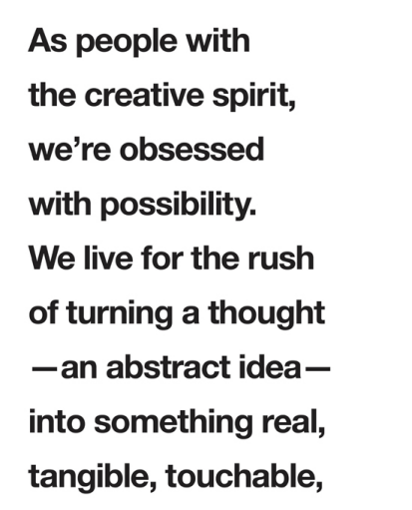
Forget about good.
Good is a known quantity.
Good is what we all agree on.
As long as you stick to good,
you’ll never have real growth.
—Bruce Mau, designer
COMPETENCY IS FOR SUCKERS
You’re probably incredibly, thoroughly competent at a number of things. You track down the best deal on flights, you know how to cook a turkey, your digital photos are organized, you know enough Spanish to get back-road directions in Oaxaca. You actually know how to pronounce Oaxaca. You hire, fire, charm loan officers, and change printer cartridges before most people have put the cream in their first coffee. You’re on top of it.
I used to tell my staff, “Be careful what you’re good at—you could end up doing it for years.” Take Ginger. She started working for me as a bookkeeper. When she came on board, receipts bulged out of tattered envelopes, tax time was looming, and I was playing one credit card off the other (a science in and of itself, as many start-up founders will attest).
Ginger was very competent, and she was as earnest and committed as the day is long. She sorted out the mess, set up maintainable systems, and even brought tulips into the office. Over time, it became radiantly clear that hiding behind Ginger’s calculator was her great, creative mind. She came up with story ideas; she made connections to the brand and the market that we hadn’t yet articulated. She thought in terms of multimedia and repurposing. She shone when we pulled her into jam sessions.
Eventually the business outgrew her bookkeeping skills and we needed to outsource to a company with a wider skill set (and faster; Ginger was never in a big rush). By that time, we had enough cash flow to pay her to contribute to the creative side of things. During the transition, she responsibly volunteered to keep doing the books until we found a suitable new money manager. “No!” I blurted out. “Just because you can, doesn’t mean you should.”
“How would it feel if you never touched another receipt again?” I asked her.
“Fucking amazing,” she confirmed. Consider it done. I dare posit that saying good-bye to competent and hello to getting paid to be her naturally talented self might have been the happiest day of Ginger’s professional life.
If it doesn’t light you up, you’re not the right person for the job. Legendary choreographer Twyla Tharp uses the athlete as a metaphor for this kind of refinement. The talented sports guy has to weigh out many factors: “What comes naturally to him, what does he enjoy the most, in which sport does he have a natural advantage? But in the end the choice should be based on pure instinct and self knowledge. What sport does he feel in his muscles and bones? What sport was he born to play?”
Would you rather be sufficient or masterful?
Would you rather be bright or a freaking supernova?
Would you rather be well-rounded or on your own leading edge?
Pure instinct and self-knowledge. If these are our guide points, then we must hold firm to what gives us joy, and in doing so, we ourselves become the dispensers of joy. The I Ching puts it this way: “The way of the Creative is to win others’ hearts through following the truth within ourselves.” Score one for sincerity and courage.
THE PRIVILEGE OF A LIFETIME
If poetry does not come as naturally as leaves to a tree, then it had better not come at all.
—John Keats
I’ll always remember a Bruce Springsteen interview I saw on MTV in the eighties. The Boss was hitting his zenith of success. Born in the USA had nonstop radio play; people were lining up days in advance to buy concert tickets. In the interview, the VJ was asking Bruce about his mega album sales and growing fortune. Jersey smooth and humble as ever, he just shook his head. “You know, man, I just can’t believe I get paid for doin’ somethin’ that comes so natural to me”—he paused —“with so much love.”
I want what he’s got! I thought. I want my fortune to be who I am. I want it to be that easy.
And that’s the stride—the life cycle of talent and return that I’ve been angling for my whole working life. I want the “privilege of a lifetime,” as Joseph Campbell called it, “of being myself.”
Once upon a time, I thought being well-rounded was the aim of the game. I wanted to be able to work any room, to be the first pick for every team, to know enough to impress anybody I sat next to in business class or partied with at a rave. I pushed myself to keep up with what was happening in the Middle East and New York Fashion Week. When my boss said I needed to master QuickBooks to be a “more well rounded” member of the team, I pulled all-nighters to figure it out. Another boss told me I needed to be more restrained, yet more outspoken. (Huh?)
One boss actually said to me, as if I should be charged with grand theft auto, “You know, Danielle, you just want to do what you’re good at.” The nerve of me! Lock me up without Wi-Fi. Just a few more years in this delusional business system and I’ll get over those pesky urges for self-gratification. Fo’ sho’.
I constantly weighed my every opinion, always scanning for the right time to insert myself into conversations. Hemmed in. Folded.
I do not want to be folded
for where I am folded,
there I am a lie.
—Rilke
I tried to become adept at bookkeeping, cooking, sewing. (I initially pursued a career in fashion design, until I noticed that I had raging headaches every time I sewed or pieced together a pattern. Loved the fashion, hated the construction.) I tried to brush up on my knowledge of wine, new physics, and the predictable interpersonal dynamics of teams. It was an anxiety-inducing curriculum of people pleasing. Identity Refinement 101. Subtle panic.
Eventually, I started giving up trying to be good at stuff that made me feel bad. Not because I was becoming more enlightened or daring, but because I was getting worn out. Task by task, attitude by attitude. The things that were fun and joy inducing in my career were getting harder to resist—begging for my fuller attention. I learned what it meant to pick my battles, and I couldn’t bear to battle with my instincts anymore. I wanted to feel in sync with The Force, not at odds with it. “Up for a challenge” was no longer cool—it was mostly a hassle. I stopped criticizing myself for not being enthusiastic about learning certain things. Getting shit from bosses proved to be entirely unavoidable, so, eventually, I got back to being my own boss.
Every admission about the things I loathed to do felt like a giant step forward for deeply ambitious humans everywhere.
Screw Excel! It’s ugly and inflexible. I’d rather figure out how to make thousands of dollars than how to count the pennies. I want to lead
people, not manage them. Most team meetings are flatlining and unproductive. Count me out.
Of course I second-guessed myself, as one tends to do on the cusp of transformation. I was actually pretty decent at figuring out IT systems and making them work. I was good at motivating staff and getting the best out of people. I was a fair meeting dominatrix and could get priorities outlined with lightning speed. I was generally very competent, thank you very much. Couldn’t competent counterbalance the lackluster feelings? Wasn’t the grind part and parcel of being a grown-up?
I began to notice I was attracted to eccentrics, crazy obsessive fanatics who immersed themselves in their creative worlds. I really liked people who admitted when they didn’t know something, “Out of my league—no idea.” What a refreshingly real response in contrast to the bullshit, empty-eyed refrains of know-it-all answers and feigned interest. Specialists intrigued me. Enthusiasts made me swoon. I wanted to be one of those Passionate People. One of Kerouac’s “mad ones”: “the ones who are…desirous of everything at the same time, the ones that never yawn or say a commonplace thing, but burn, burn, burn like fabulous yellow Roman candles exploding like spiders across the stars …” Slam. Poetry.
A chilled-out but insistent voice kept reminding me: “You didn’t sign up for good enough in this lifetime, you signed up for awesome.” Right. Got it. Awesome. And I deftly concluded:
Who are you trying to impress?
What do you have to force yourself to do?
What would you like to never, ever do again?
APPROVE OF YOUR WEAKNESSES
If you’ve got the strength and pride to fly your superhero flag, then you also have the mettle to admit to what you suck at. Such admissions have lasting benefits.
WHEN YOU COP TO YOUR SHORTCOMINGS
You become accessible. Humanity is charming. What, you’re not superhuman? Well then let’s be friends.
You make space for other people to perform, shine, and operate from their true strengths—a living inspiration.
You foster teamwork and collaboration.
You get the benefit of other people’s greatness.
You create a genuine connection.
You get help. People support you.
You actually don’t have to do it all. Go figure.
You give yourself permission to pursue your genius.
AU NATUREL
Jonathan Livingston Seagull…was no ordinary bird. Most gulls don’t bother to learn more than the simplest facts of flight—how to get from shore to food and back again. For most gulls, it is not flying that matters, but eating. For this gull, though, it was not eating that mattered, but flight. More than anything else, Jonathan Livingston Seagull loved to fly.
—Richard Bach, Jonathan Livingston Seagull
When you focus on building your natural strengths and doing what comes easiest to you, you gain a momentum in your life that feels efficient and exciting and hot. Like, sexy kind of hot, and deeply nourishing kind of hot; like your heart on fire kind of hot. The kind of hot we all want to feel. Are you with me?
True strength is not necessarily about skill or adeptness. It’s about vitality. Holding this perspective changes everything, my friend. And it goes back to my root theory in life—that our actions are driven by our desire. It means that all that stuff that you may be good at but don’t really love to do, you get to dump…mostly. No more faking it to make it.
With his books Now, Discover Your Strengths and The Truth About You, Marcus Buckingham is a true-strengths zealot. He puts it this way: “A strength is what you do that makes you feel strengthened.” Boom. So it’s not necessarily what you’re good at or what you’re capable of—
it’s what feels amazing when you do it. Ergo, a weakness is the stuff you do that makes you feel weakened. Deceptively simple. Revolutionary.
According to Buckingham—and I couldn’t agree more—we will never be great at the things we have to try to be good at. But we can be amazing at the things we’re easily great at. I vote for outstanding. Can I get a witness?
When my awesomesaucey son was about four years old, we went to a local ice cream parlor for a treat. It was a soft summer evening, just perfectly perfect, and we sat in the parlor’s garden, under twinkly lights, licking our cones, not saying much. “So, Monkey,” I said through chocolate licks, “what’s it feel like to be alive, like, how’s your life?” And without missing a beat, and with a slight cowboy lilt, he replied, “Oh, Mama! It’s ahhh-MAZing. If I were a telephone, I’d be ringin’ all the time!” Attaboy.
WORK YOUR PASSION
Masters focus on what they do best. That’s how they become masters. They stay in their zone, and the zone is what feels good. Damn good. So what about good, old-fashioned sweat and determination? It’s essential, of course. But there is a remarkable difference in slogging to fit the bill and pushing yourself to break the mold. There’s being obligated to run hard versus wanting to run hard. There’s duty, and there’s passion. And you can’t fake passion.
Passion will always
move you in the direction
of your authentic self.
Passion guarantees
you a place in the hero’s journey action course. It helps you know what to say yes or no to. No more trying to be a marketing genius when what you do best is negotiating with vendors or pumping up the sales team—hire a PR genius. No more faking that you love to cook so you’ll look like a better parent or partner. Give yourself permission to keep it basic. (And count me in. Most meals at my house are picnics in the living room.) No more trying to come up with blue-sky, five-year plans when you’re a short term, focused-details guy —get a coach or a
FOR THE LOVE OF LIGHT When do you feel ahhh-MAZing? What makes you ring?!
What activities cause you to feel useful, vital, better than before?
When do you have that “there’s more where that came from” feeling?
What feels so good and so easy to give that you give it generously?
What do you do best—that gives you a rush while you’re doing it?
What lights your fire?
visionary friend to help you see the big possibilities.
And, by the way, passion doesn’t need to be constantly fiery and all consuming; it can be a steady curiosity and commitment. You don’t need to want to die for your calling or chain yourself to a tree for your cause. Genuine curiosity and sincere interest are burning coals that can warm you for a good, long time.
Your curiosity is your growth point. Always.
You grow most in your areas of greatest strength. You will improve the most, be the most creative, be the most inquisitive, and bounce back the fastest in those areas where you have already shown some natural advantage over everyone else—your strengths. This doesn’t mean you should ignore your weaknesses. It just means you’ll grow most where you’re already strong.
—Marcus Buckingham, Now, Discover Your Strengths
This is akin to what Stephen Covey called “sharpening your saw” in his oldie but goody, The 7 Habits of Highly Effective People. I adore this concept: Get better at what you’re best at.
Go deeper. When you deepen your interests and stretch your talents, the world feels bigger and full of even more promise. You’ll be able to see more, grasp more, catch the nuances of your psyche, and make connections with the greater whole. When you’re honoring your own drive, you’ll be more compassionate. And, ironically, when you strive for mastery, you become more accessible. Aspiring to something greater always makes you more vulnerable. And it’s that kind of openness that allows for learning to occur.
I try to collaborate with people who operate from their zone of true strengths so that I can learn from the best—from people who are being their best. And so I can be seen and called out and polished up when I’m shrinking, faking, or faltering.
HOW CAN YOU TELL IF SOMEONE IS IN THEIR ZONE? They show up because they’re compelled to—they can hardly resist.
They ask really good questions because they’re always scanning for the right fit.
They’re really comfortable saying no to things that pull them away from what they love.
They’re incredibly generous.
They look you in the eye.
INVEST IN YOUR SECOND NATURE
Your original self and all its great capacities are present from day one. Jungian analyst James Hillman calls it “the acorn theory.” It is the idea that we are born with a soul that shapes our destiny—that our full potential already lives within us. That potential may lie dormant until your life conditions become the ideal environment for you to sprout… until you’re big enough to run the race, or you have the vocabulary to better argue your point, or until the right teacher comes along to stretch your mind to its fuller proportions.
For some of us, growth-conducive circumstances happen in childhood thanks to both inner talent and outer surroundings. It can be difficult to tell which comes first—the talent or the conditions. Take Venus and Serena Williams, for example, whose father had visions of Wimbledon trophy plates for his babies and had them swinging tennis rackets as soon as they could walk. For others, the lightning flash of potential might not show up until later in life. Diana Krall, one the world’s best-selling jazz artists, didn’t start singing until she was twenty-six. The literary virtuoso Colette didn’t pick up a pen to write fiction until she was more than fifty.
Hillman explains: “The acorn theory expresses that unique something that we carry into the world, that is particular to us.” It is connected to our daimon, a Greek word scarcely used in our culture, which loosely translates to “inner voice.” The Roman word was genius, and the Christian word is guardian angel. What if instead of looking to
our genes, our social class, or the expectations of the household we grew up in, our whole educational system focused on each child discovering his or her very own daimon? The model would be one of eliciting and evoking, rather than molding and configuring. What if every individual was considered a mystery to observe and support, rather than a vessel to fill with outside information?
Can you remember who you were, before the world told you who you should be?
NORMAL IS BORING
The need to be normal is the predominant anxiety disorder in modern life.
—Thomas Moore, Original Self
Naturally driven excellence is not “normal,” by the way. Most amazing people are a tad eccentric or obsessive. A little off-kilter. Driven. Devoted. (Nowhere in the definition of devoted do the words balanced, measured, or normal appear.) Freaky excellent people do not have subtle strengths, they have pronounced talents or proclivities, and they have a rabid dedication, a flaming ardor for what they do so well. They dig it, and they dig it hard.
Though unmitigated, unapologetic stupendousness is the exception rather than the norm in our culture, champions of authenticity can be found in every profession or calling. Bakers, day-care teachers, technologists, activists—everyone has some form of genius to rock. And when you’re letting your genius fly, you make it look so natural. Because it is.
PASSION PLAY
WORKSHEET
Your true strengths are living right here.
What are you intensely interested in? While you’re at it, include your moderate curiosities.
You go to the best cocktail party ever. It’s a life-changing event because you meet the most with-it, interesting, empowered people, and each of them can contribute to your career and interests in some way.… Who was there? What kind of information did they share with you? What did they ask you? How did they offer to help you?
If you could go to five conferences or events this year, which ones would you go to, or what would they be about?
What could you talk about late into the night with like-minded people without running out of things to say?
What activities make you feel really useful, alive, and strong? When do you feel like a rock star, a gifted contributor, a very cool and purposeful human being? In terms of things that you do, when do you feel most like yourself?
What do you want to be known for?
A WORD ON LIFE PURPOSE
So many people are looking for it: their Big Life Purpose. Becoming YOU is your purpose.
YOU are the very purpose of your existence. Realizing what lights your fire and floats your boat—that’s your life purpose. What else could it be?
If it gives you true joy (not the seemingly happy high that is fleeting, but the reliable, always-there kind of satisfaction) to rock that guitar, to make people laugh, to discover the world, to make things a little more beautiful wherever you go, to feed, to stir it up, to clean it up, to execute the plan, to bank the cash, to be a compassionate citizen, to explore nonstop, or purely to seek pleasure…then, that’s your life purpose!
Your life purpose is what you say it is.
Who could tell you otherwise?
An integral being knows without going,
sees without looking, and accomplishes without doing. —Lao-tzu
Take a nap
Making the mountain water
Pound the rice.
— Kobayashi Issa
What would your life be like if you did only what was easy? Let me repeat the question:
It’s almost unsettling to go there, isn’t it? When I try to answer that question for myself, I squirm a bit. Lazy dilettante. As if. What would I do with all that extra time I’d have if I just did the easy stuff? Hmmm… maybe I’d have more time to enjoy what I’ve got and get more of what I want. Maybe things would be…easier.
Ease. The concept confounds most of us. Here’s why:
Pay your dues. Put in your time. Prove yourself. Check the right box. Stay the course. Meet expectations. Soldier on. Nothing worthwhile comes easily. Good things come to those who wait. Blue collar, white collar, hard work pays off. No pain, no gain. Thomas Edison put it this way: There is no substitute for hard work.
We’ll call these, collectively, the Myth of Endurance: a concept that you can choose to believe in, in varying degrees, or not. “Easy” is also a concept that can be just as useful to you. The easy way is a direction that leads to spacious places.
Choosing easy is smart, efficient, elegant; a fantastic form of self compassion; giving yourself a break and getting out of your own way. Choosing easy is letting inspiration be your compass. Choosing easy is allowing for the things that you’ve been asking for to enter your life.
Now, let’s be clear, there are two types of easy. Quality easy and cheap easy. We’re aiming for Quality, with a capital Q.
THE QUALITY KIND OF EASY
Quality easy has a sense of fluidity to it. There’s a gravitational pull forward. Quality easy relies on his inner strength. Quality easy has an abiding respect for herself.
Quality easy has fewer things on the to-do list and is a brilliant delegator. Quality easy trusts the timing of things. He knows it’s better to hold out for what’s right than to deal with the mess of extracting himself from a bad compromise. The minute resentment and irritation set in to a task, Quality easy goes on red alert. She steers clear of aggravation, annoyance, and repetitive misery. Over time, Quality easy gets comfortable saying no, thank you, to things that are just too complicated and too distant from what she really wants. She is willing
to let it go, get over it, and walk away—because she has better things to do with her life energy. It’s that simple, most of the time. Quality easy brings a sense of expansion to things. Quality easy is compelling—because when you say yes to grace, you’re saying yes to the natural flow of life. You lift your face toward the divine, like flowers lean into the light.
THE CHEAP KIND OF EASY
Cheap is a sucker for a discount. Cheap easy can’t see that some losses are gains. Cheap easy stays in a stifling relationship because it seems easier than facing the heartbreak and dividing up the furniture. Cheap easy is frequently in a rush, a smidge desperate, and usually scrambling for options. Cheap easy tells little white lies to get things done.
The path of least resistance isn’t about shortcuts, cutting corners, or being clever. And it’s certainly not about making mediocrity acceptable. It’s about optimizing the truth. It’s about casting your seeds on the most fertile soil for your best chances for success.
START WITH THE EASY STUFF
Easy is sublimely logical. Consider all of the things you want to create, produce, accomplish, put out in the world, and experience—so many roads that could lead to satisfaction. Start with the project or the aspect of the project that is the easiest. What do you already know the most about? Where are there already ambassadorships and alliances? What are people already asking you for?
The same goes for creating satisfying relationships. What’s already going well that you can lean in to? What do you adore about the other person that you can focus on? The easy stuff is right in front of you and totally doable: simple kindnesses freely given day to day. Start there and you can approach the big hairy issues with some lightness.
Instant gratification has gotten a bad rap. I’m all for it. Why would you want to delay gratification? Within the constraints of morality and
maturity, you should do whatever you need to do to feel gratified in the moment. It may be as subtle as choosing a more positive thought or reminding yourself to smile. Maybe it’s taking two minutes in your car or at your desk to do nothing but just feel into the day. Maybe instant gratification is fifty sit-ups for an adrenaline rush, ordering dessert first, giving an unexpected hug, signing the lease, or telling your boss to shove it. You can be responsible to those around you while creating immediate pleasure for yourself.
Pleasure makes everything easier. Gratification builds the momentum, motivation, and muscle for you to choose the work ahead of you that will require more patience and stamina. It warms you up to shine.
My creativity coach and friend Dyana Valentine is an ambassador of the easy way. “If it doesn’t feel easy and juicy, then you’re automatically dropping your operation percentage down to about 80 to 70 percent.” She’s 100 percent right.
TAKE THE EASY WAY UP
Less friction = greater velocity. When you start with the easy stuff, you foster optimism. You’re less stressed and more juiced. Less obligated and more devoted. You get more done. When it’s easy for you, you can be of greater service to the people around you.
There’s a charming cartoon sketch that shows this little guy standing at the base of Mount Everest. He’s
staring in awe at a secret, hidden stairway that’s been built into the backside of the mountain. It leads straight up to the peak. The sign next to it says LITTLE-KNOWN ENTRANCE.
PROCRASTINATION CAN BE DIVINE
Procrastinating is easy, and that’s a fact. And even type-A personalities and productive grown-ups put things off. But what we might critique as procrastination can actually be a misdiagnosis for instinct.
One of the effects of living in a hyperproductive society is that intuitive resistance can get labeled as procrastination. But what seems like avoidance may be a deeper inkling of wrong timing.
Hesitation can be a form of wisdom. Motives become clearer; new information shows up. Amazing grace can happen when you choose inner rhythms over external pressure.
ENTHUSIASM SAVES LIVES
You know what’s easy? Dreaming. Hanging out with people who make you feel good. Laughing. Resting. Being passionate.
Sometimes you have to shovel horse apples to make your dreams come true. But, ultimately, no dream will serve you if you’re forcing yourself to make it happen.
Enthusiasm is a fantastic indicator of where your true strength lives. It’s the immediate “I love it!” response, the game you’ve got to get into, the cause you can’t walk away from, the idea that makes you pause and then nod, “Oh, this is a good one, a really good one.” Enthusiasm evokes a determined “no matter what-ness.” It wakes us up in the middle of the night with fresh ideas. Enthusiasm creates a flurry of connections and marvelous events that often starts with this powerful little phrase: “What if …”
Enthusiasm is a heightened state of consciousness, and it’s one of the best feelings there is to feel.
Whenever there is enthusiasm, there is a creative empowerment that goes far beyond what a mere person is capable of.
—Eckhart Tolle, A New Earth
The word enthusiasm comes from the Greek root entheos, “having the god within.” Eckhart Tolle suggests that enthusiasm is the highest form of “awakened doing.”
Eckhart outlines three modalities of awakened doing: acceptance, enjoyment, and enthusiasm. Acceptance means being in the situation and doing what must be done willingly. Enjoyment happens when you are fully present and not just doing what you’re doing as a means to an end. It’s not what you do, but how you do it. Enthusiasm means that there is a deep enjoyment in what you do, plus a goal or a vision you’re working toward. Enthusiasm knows where it’s going.
Is that not cosmic fabulousness? So elegant and simple. So obviously essential to whole living.
Of course, you can’t be in a continual state of enthusiasm. You’d fry, fall, and lose your grounding. But before you commit, sign, take the stage, take the meeting, take the gig, or take your place in the intentional unfolding of your life, enthusiasm must be present. Ideally. And we’re going for ideal here.
My great friend Marie Forleo, founder of the Rich Happy & Hot LIVE events, has her own kind of enthusiasm policy for how she chooses her projects: if it isn’t a “Hell yes!,” then it’s a no. Enthusiasm is the genuine Yes! that will uncork your genius, signal your muses to come down, and magnetize the resources you need to be within your reach. Enthusiasm is the beautiful beginning that changes everything.
HAVE BRIGHT FAITH
Buddhists have a term for a particular kind of enthusiasm that happens with new ideas and events: bright faith. This is not the bedrock kind of faith that grounds your psychology, spirituality, or devotion. It’s not the assurance/insurance kind of faith where we hope/trust that life will come through for us.
It’s the Holy cow, I’m standing at the beginning of something that is so insanely ripe with potential that I wanna get naked and roll all over it right now while singing rock opera…kind of faith. It makes you grin silly grins and do uncharacteristically impulsive and obsessive things. Bright faith is exhilarated.
Buddhist teacher Sharon Salzberg says, “This is a state of love-filled delight in possibilities and eager joy at the prospect of actualizing them. Bright faith goes beyond merely claiming that possibility for oneself to immersing oneself in it.… The enthusiasm, energy, and courage we need in order to leave the safe path, to stop aligning ourselves with the familiar and convenient, arise with bright faith.”
Bright faith is primal to creativity. Bright faith is essential to falling in love—with people, with causes, with your own perfectly perfect self. Bright faith can be unnerving, slightly embarrassing, and awkward. We are trained to resist it, and we do so at the cost of innovation and the passion we crave.
THE CLARITY THAT CRAZY BRINGS
Here’s a headline for a life résumé: “Selectively but wildly excitable.” I adore exclusively stoked people. They’re discerning—not everything is
a great opportunity; in fact, golden ops are rare. But when they see something that glimmers with uniqueness or resonates with their reason for being, they start to move.
This is how brainstorming goes with brightly faithful people: “Hmmm. Uh-huh. Nope. Nah. No. Nope. Nope. Nope. Nope. Ooh. Ahh. Wait a second. Holy shit, yes, yes, yes, oh my God, we could…and then we could…and it would be so…and holy yes and…I’ll sell it all if I have to…and what am I going to wear when I accept the award?! Who will we invite to the wedding?! How big do you think we can build it? Excuse me while I make a phone call.”
They go off.
It’s illogical, grandiose, crazy, and most certainly romantic. It’s faith. But these are the essential ingredients for breaking through mediocrity and cynicism. Bright faith is a divine kind of madness and it feels so good if we don’t judge it. And what the über-realists of the world don’t quite get is that the chaotic sparks of bright faith actually burn a path to clarity of mind.
To create things of beauty—in form or between two people—is a passion-first, discrimination-second formula. And yep, it’s dangerous.
COOL IS DULL
If I have to choose between two service providers with similar skill and equal pricing, I’ll always go with the one who freely expresses his or her excitement. I did a gig with someone who said, “Oh, my God, I’m so excited to work with you! I’m going to hang up the phone and do the happy dance.” She was so uncool about it all. No pretense—just joy and bright faith in how much fun we could have. So then I said, “Me, too! Now I’m really stoked. I’ll do the happy dance when I hang up, too. Let’s do this!”
My best strategic meetings have been the most uncool. Whether they’re construction contractors, publishers, or florists, they’re unself conscious and eager. They’re stoked to be there and they say so.
Bright faith shows up at the beginning—that extremely precious and fractional space when you need as much light as you can to see which
way you want to go. The more possibilities you let shine—the more you shine with possibility—the more lucid and discerning you can be. It’s that easy.

